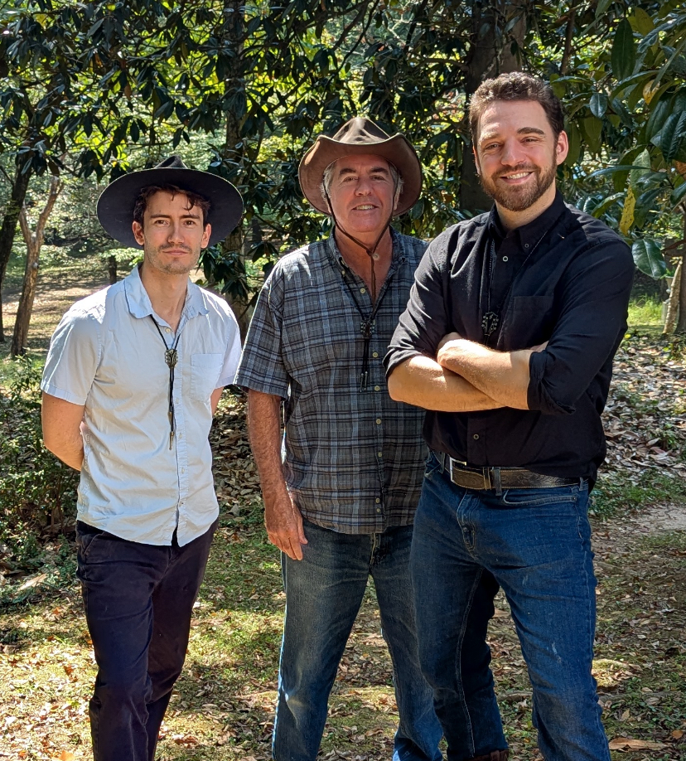
Thanks for listening!

Bolo Boys

Like what you hear?
Got song requests?
Want to book us?

Let’s stay in touch
Instagram | YouTube | Email
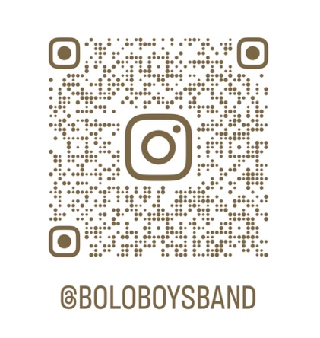 | 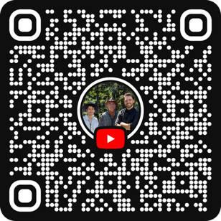 | FrothMGMT  @  Gmail.com

